**Walks near Burnbrae Dryburgh to St Boswells to Mertoun Bridge loop 7.25km 4.5miles**

A lovely walk for anytime of year. The well marked path is mainly level along the river bank. There is a car park and toilets at Dryburgh Abbey, (at the abbey not the hotel). Or the loop can be started from St Boswells. I recommend Main Street Trading a delicious café in the center of St Boswells for that well deserved coffee or post walk lunch.

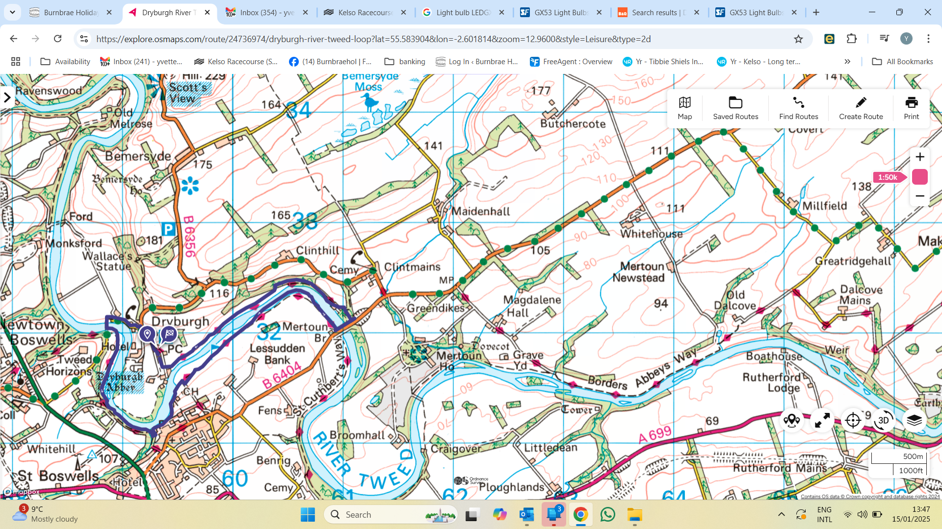

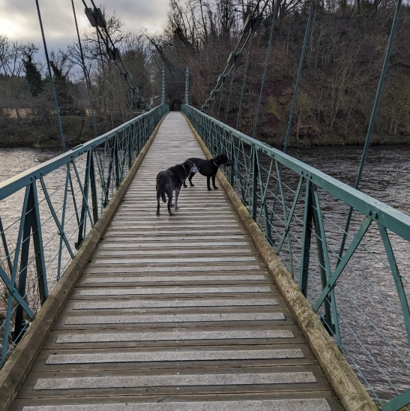

From Dryburgh Abbey, Abbey car park, not the hotel car park, walk following the road back out the way you’ve driven in, slightly up hill. Turn left along the single track tarmac road. Notice the amazing stone gateway into a sheep field on the bend. Carry on to the footbridge. Cross the River Tweed on the foot bridge.

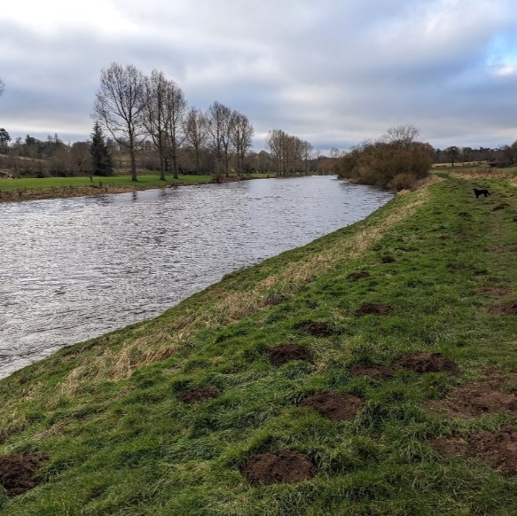Turn left along the river. Follow the path, at times on footbridges along the River Tweed. To stop in St Boswells walk uphill along one of the many paths into the town.

Rejoin the route taking the path along the riverside where there is a choice of paths. Eventually the path leads down to St Boswells Golf course. Cross the golf course to continue east along the river.

Next to a house, cross the River Tweed using the Mertoun road bridge.

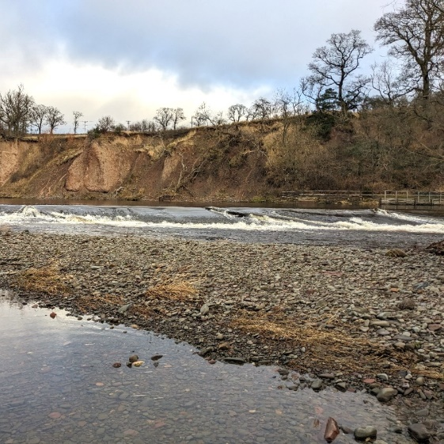At the north side of the river, follow the wooden steps up the left side of the road into a group of trees. Then follow the left track which leads to a gate in to a field. At the far side of the field go through a pedestrian gate onto a track. Follow the track down towards the river. Follow this path all the way back to Dryburgh Abbey, turning right after a style on to the driveway.